ENERGY EFFICIENT AND ROBUST ROUTING[unit-4 WSN]
Information routing in wireless sensor networks can be made robust and energy-efficient by taking into account a number of pieces of state information available locally within the network.

1. Link quality: link quality metrics (e.g. packet reception rates) obtained through periodic monitoring are very useful in making routing decisions.

2. Link distance: Particularly in case of highly dynamic rapidly fading environments, if link monitoring incurs too high an overhead, link distances can be useful indicators of link quality and energy consumption.

3. Residual energy: In order to extend network lifetimes it may be desirable to avoid routing through nodes with low residual energy.

4. Location information: If relative or absolute location information is available geographic routing techniques may be used to minimize routing overhead.

5. Mobility information: Recorded information about the nearest static sensor node near a mobile node is also useful for routing.

Metric-based approaches

Robustness can be provided by selecting routes that minimize end-to-end retransmissions or failure probabilities. This requires the selection of a suitable metric for each link.
The ETX metric

If all wireless links are considered to be ideal error-free links, then routing data through the network along shortest hop–count paths may be appropriate. However, the use of shortest hop–count paths would require the distances of the component links to be high. In a practical wireless system, these links are highly likely to be error-prone and lie in the transitional region. Therefore, the shortest hop–count path strategy will perform quite poorly in realistic settings. This has been verified in a study , which presents a metric suitable for robust routing in a wireless network. This metric, called ETX , minimizes the expected number of total transmissions on a path. Independently, an almost identical metric called the minimum transmission metric was also developed for WSN.

It is assumed that all transmissions are performed with ARQ in the form of simple ACK signals for each successfully delivered packet. Let df be the packet reception rate (probability of successful delivery) on a link in the forward direction, and dr the probability that the corresponding ACK is received in the reverse direction. Then, assuming each packet transmission can be treated as
a Bernoulli trial , the expected number of transmissions required for successful delivery of a packet on the link is:
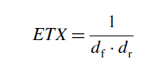
Figure 8.1 shows three routes between a given source A and destination B, each with different numbers of hops with the labelled link qualities (only the forward probabilities are shown, assume the reverse probabilities are all dr =1).
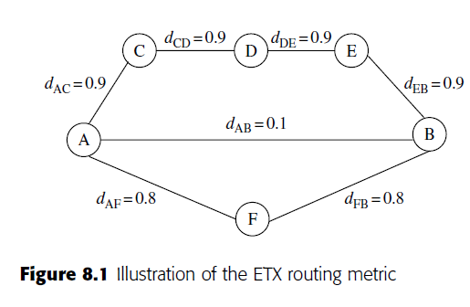
The direct transmission from A to B incurs 10 retransmissions on average. The long path through nodes C, D, and E incurs 1.11 retransmissions on each link, hence a total of 4.44 retransmissions. The third path, through node F, incurs 1.25 retransmissions on each link for a total of 2.5 retransmissions. This is the ETX-minimizing path. This example shows that ETX favors neither long
paths involving a large number of short-distance (high-quality) links, nor very short paths involving a few long-distance (low-quality) links, but paths that are somewhere in between.
The ETX metric has many advantages. By minimizing the number of transmissions required, it improves bandwidth efficiency as well as energy efficiency. It also explicitly addresses link asymmetry by measuring reception probabilities in both directions.

Routing with diversity
A set of techniques exploits the diversity provided by the fact that wireless transmissions are broadcast to multiple nodes.
Relay diversity

The authors of also propose and analyze the reliability–energy tradeoffs for a simple technique for providing diversity in wireless routing that exploits the wireless broadcast advantage. This is illustrated in Figure 8.2 by a simple two-hop route from A to B to C. With traditional routing, the reliability of the path is purely a function of whether transmissions on A and B and B and C were
both successful. However, if C is also allowed to accept packets directly from A (whenever they are received without error), then the reliability can be further increased without any additional energy expenditure.
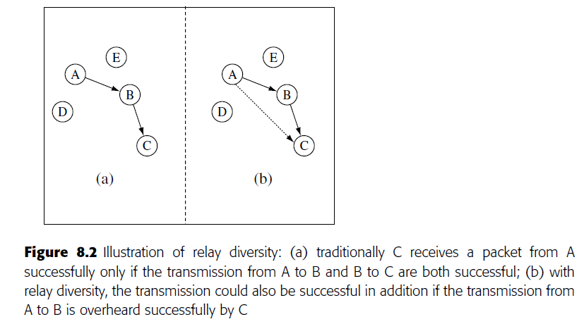
Extremely opportunistic routing (ExOR)

A related innovative network layer approach to robust routing that takes unique advantage of the broadcast wireless channel for diversity is the extremely opportunistic routing (ExOR) technique. Unlike traditional routing techniques, in ExOR the identity of the node, which is to forward a packet, is not pre-determined before the packet is transmitted. Instead, it ensures that the node closest to the destination that receives a given packet will forward the packet further. While this technique does not explicitly use metric-based routing, the protocol is designed to minimize the number of transmissions as well as the end-to-end routing delay (Figure 8.3).
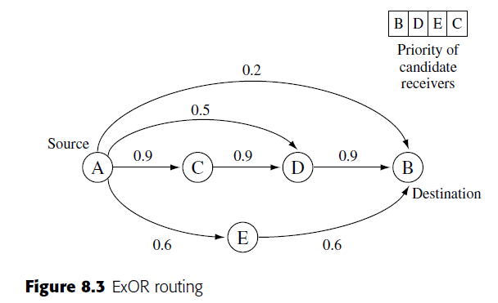
In detail, the protocol has three component steps:

1. Priority ordering: At each step, the transmitter includes in the packet a schedule describing the candidate set of receivers and the priority order in which they should forward the packet. The candidate list and ordering are constructed to ensure high likelihood of forward progress, as well as to ensure that receivers that lie on shorter routes to the destination (which are also generally the closest to the destination) have higher priority.
2. Transmission acknowledgements: A distributed slotted MAC scheme is used whereby each candidate receiver sends the ID of the highest-priority successful recipient known to it. All nodes listen to all ACK slots. This constitutes a distributed election procedure whereby all nodes can determine which node has the highest priority among the candidates that received the packet successfully.
Even if a node does not directly hear the highest-priority node’s ACK, it is likely to hear that node’s ID during another candidate’s ACK.
Thus, by transmitting the IDs as per this protocol, and having all nodes wait to receive all ACKs, an attempt is made to suppress duplicate forwarding to the greatest extent possible.
3. Forwarding decision: After listening to all ACKs, the nodes that have not heard any IDs with priorities greater than their own will transmit. There is a small possibility that ACK losses can cause duplicate transmissions; these are further minimized to some extent by ensuring that no node will ever retransmit the same packet twice (upon receiving it from different transmitters).
Multi-path routing
One basic solution for robustness that has been proposed with several variations is the use of multiple disjoint or partially disjoint routes to convey information from source to destination. There is considerable prior literature on multi-path routing techniques; we will highlight here only a few recent studies focused on sensor networks.
- Braided multi-path routing
A good example of the use of localized enforcement-based routing schemes, such as Directed Diffusion to provide for multi-path robustness, is the “braided multi-path” schemes for alternate path routing in wireless sensor networks. In alternate path routing, there is a primary path that is mainly used for routing and several alternate paths are maintained for use when a failure
occurs on the primary path. A braided path is one where node disjointedness between the alternate paths is not a strict requirement. It is defined as one in which for each node on the main path there exists an alternate path from the source to the sink that does not contain that node, but which may otherwise overlap with the other nodes on the main path. The braided multi-path construction is compared with a localized disjoint multi-path construction in the study [58] in terms of resiliency to both isolated and pattern failures, as well as the overhead required for multi-path maintenance (which is assumed to be proportional to the number of participating nodes). While the disjoint multi-path techniques have greater resiliency to pattern failures than
the braided multi-path techniques (which suffer due to the geographic proximity of all alternate paths), this comes at the expense of significantly greater overhead. Particularly for isolated failures, the braided approach can be significantly more resilient and energy-efficient.

- Gradient cost routing (GRAd)

The gradient routing technique (GRAd) , provides a simple mechanism for multi-path robustness. All nodes in the network maintain an estimated cost to each active destination (this set would be restricted to the sinks in a sensor network). In the simplest case, the cost metric would be just the number of hops; however, the protocol can be enhanced to handle other metrics. When a packet is transmitted, it includes a field that indicates the cost it has accrued to date (i.e. number of hops traversed), and a remaining value field, that acts as a TTL (time-to-live) field for the packet. Any receiver that receives this packet and notes that its own cost is smaller than the remaining value of the packet can forward the message, so long as it is not a duplicate. Before forwarding, the accrued cost field is incremented by one and the remaining value field is decremented by one (in the case of hop-count metric, the increment/decrements would be accordingly different for other metrics). One issue that needs to be taken into account in practice is that in the basic GRAd scheme cost fields are established using a reverse-path approach, which assumes the existence of bidirectional links.
Since GRAd allows multiple nodes to forward the same message, it acts essentially as a limited directed flood and provides significant robustness, at the cost of larger overhead.

- Gradient Broadcast routing (GRAB)

The Gradient Broadcast mechanism (GRAB) [236] enhances the GRAd approach by incorporating a tunable energy–robustness tradeoff through the use of credits. Similar to GRAd, GRAB also maintains a cost field through all nodes in the network. The packets travel from a source to the sink, with a credit value that is decremented at each step depending on the hop cost. An implicit credit-sharing mechanism ensures that earlier hops receive a larger share of the total credit in a packet, while the later hops receive a smaller share of the credit. An intermediate forwarding node with greater credit can consume a larger budget and send the packet to a larger set of forwarding eligible neighbors. This allows for greater spreading out of paths initially, while ensuring that the diverse paths converge to the sink location efficiently. This is illustrated in Figure 8.4, which shows the
set of nodes that may be used for forwarding between a given source and the sink.
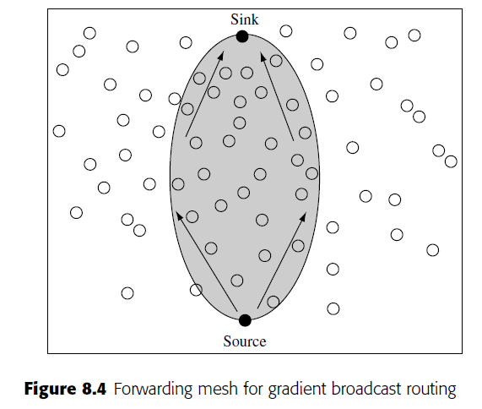

Lifetime-maximizing energy-aware routing techniques
A number of studies have explored the issue of energy aware, lifetime maximizing routing approaches for wireless ad hoc and sensor networks. Many of these are based on identifying and defining suitable shortest-path link metrics, while some derive energy-efficient routes for a network using a global optimization formulation.

- Power-aware routing

In an ideal, lightly loaded environment, assuming all links require the same energy for the transmission of a packet, the traditional minimum hop-count routing approach will generally result in minimum energy expended per packet. If different links have uneven transmission costs, then the route that minimizes the energy expended in end-to-end delivery of a packet would be the shortest
path route computed using the metric Tij , the transmission energy for each link i j. However, in networks with heterogeneous energy levels, this may not be the best strategy to extend the network lifetime (defined, for instance, as the time till the first node exhaustion).
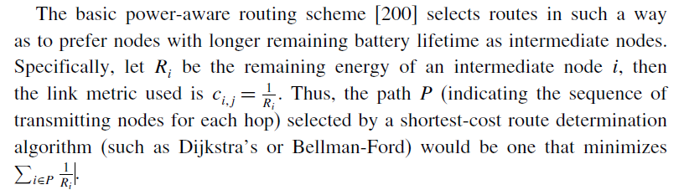

- Lifetime-maximizing routing

While minimizing per-hop transmission costs minimizes total energy, avoiding nodes with low residual energy prevents early node failure. However, considering these goals separately, as in the above, may not optimize the system lifetime. What is needed is a technique that balances the two goals, selecting the minimum energy path when all nodes have high energy at the beginning, and avoiding the low residual energy nodes towards the end.
- Load-balanced energy-aware routing

In order to provide an additional level of load balancing, which is necessary in a static network, the following cost-based probabilistic forwarding mechanism can be used. Nodes forward packets only to neighbors that are closer to the destination.

Geographic routing

Since location information is often available to all nodes in a sensor network (if not directly, then through a network localization algorithm) in order to provide location-stamped data or satisfy location-based queries, geographic routing techniques are often a natural choice.

- Local position-based forwarding

The simplest version of geographic forwarding, described by Finn , is to forward the packet at each step to the neighbor that is closest to the destination (the location or ID of this neighbor is marked in the packet, based on neighborhood information obtained through a beaconing process). There are several variants of this greedy forwarding mechanism. In the most forward within R strategy (MFR) , the packet is forwarded to the neighbor whose projection on the line joining the current node and the destination is the farthest (note that this is not always the same as the greedy forwarding). In another variant, the packet is forwarded to the nearest neighbor with forward progress (NFP) , so that contention can be minimized and the wireless link quality is high. Yet another variant is the random-forwarding technique in which the packet is forwarded at random to a neighbor so long as it makes forward progress. We should also note that the ExOR technique, described above, is a form of implicit greedy geographic forwarding, which does not require beaconing – the timers are designed so that packets are likely to be forwarded (only) by the node closest to the destination that receives the packet correctly.

- Perimeter routing (GFG/GPSR)

One major shortcoming of the greedy forwarding technique is that it is possible for it to get stuck in local maxima/dead-ends. Such dead-ends occur (see Figure 8.5) when a node has no neighbors that are closer to the destination than itself. For this case, the greedy-face-greedy (GFG) algorithm , which is the basis of the greedy perimeter stateless routing protocol (GPSR) , routes along the face of a planar sub-graph using the right-hand rule. The planar sub graph can be obtained using localized constructions such as the Gabriel graph and the relative neighbor graph constructions. A packet switches from greedy to face-routing mode whenever it reaches a dead end, is then routed using face routing, and then reverts back to greedy mode as soon as it reaches a node that is closer to the destination than the dead-end node. Other studies have examined ways to improve upon and get provable efficiency guarantees with face-routing approaches. It should be kept in mind, however, that the likelihood that such dead ends exist decreases with network density; it can be shown that, if the graph is dense enough that each interior node has a neighbor in every 2π/3 angular sector, then greedy forwarding will always succeed .
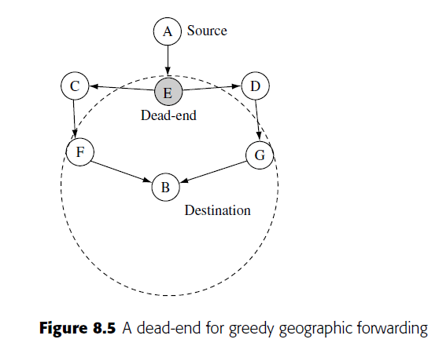
- Geographical energy-aware routing (GEAR)

The geographical and energy-aware routing mechanism (GEAR) is designed to propagate queries/interests from a sink to all sensor nodes in a geographically scoped destination region (e.g. a square sub-area with specified bounds). The packets are routed from the origin to the destined region through a series of forwarding steps, which make use of an adaptive learned cost function for each neighbor that is modified over time to provide a balance between reachability and energy efficiency. This approach also provides robustness to dead ends. When the packet reaches the destination region, a recursive forwarding technique is employed as follows. The region is split into k sub-regions, and a packet is forwarded to each sub-region. This split–forward sequence is repeated
until the region contains only one node, at which point the packet has been successfully propagated to all nodes within the query region. Finally, we should mention in this section the trajectory-based forwarding technique (TBF),which is also an important geographic routing technique for sensor networks. As a significant application of TBF applies to the routing of queries.
Routing to mobile sinks
Mobility of nodes in the network adds a significant challenge. The study of routing over mobile ad hoc networks (MANET) has indeed been an entire field in itself, with many protocols such as DSR, AODV, ZRP, ABR, TORA, etc. proposed to provide robustness in the face of changing topologies
. A thorough treatment of networking between arbitrary end-to-end hosts in the case where all nodes are mobile is beyond the scope of this text. However, even in predominantly static sensor networks, it is possible to have a few mobile nodes. One scenario in particular that has received attention, is that of mobile sinks. In a sensor network with a mobile sink (e.g. controlled robots or humans/vehicles with gateway devices), the data must be routed from the static sensor sources to
the moving entity, which may not necessarily have a predictable/deterministic trajectory. A key advantage of incorporating mobile sinks into the design of a sensor network is that it may enable the gathering of timely information from remote deployments, and may also potentially improve energy efficiency.
- Two-tier data dissemination (TTDD)

In the two-tier data dissemination (TTDD) approach , all nodes in the network are static, except for the sinks that are assumed to be mobile with unknown/uncontrolled mobility. The data about each event are assumed to originate from a single source. Each active source creates a grid overlay dissemination network over the static network, with grid points acting as dissemination nodes (see Figure 8.6). A mobile sink, when it issues queries for information, sends out a locally controlled flood that discovers its nearest dissemination point. The query is then routed to the source through the overlay network. The sink includes in the query packet information about its nearest static neighbor, which acts as a primary agent. An alternative immediate agent is also chosen when the sink is about to go out of reach of the primary agent for robust delivery. The source sends data to the sink through the overlay dissemination network to its closest grid dissemination node, which then forwards it to its primary agent. As the sink moves through the network, new primary agents are selected and the old ones time out; when a sink moves out of reach of its nearest dissemination node, a new dissemination node is discovered and the process continues.
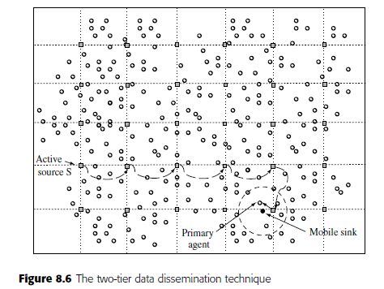
- Asynchronous dissemination to mobile sinks (SEAD)

The scalable energy-efficient asynchronous dissemination technique (SEAD) presented in provides for communication of information from a given source in a static sensor network to multiple mobile sinks. Each mobile sink selects a nearby static access node to communicate information to and from the source. Only the access node keeps track of sink movement, so long as it does not move too far away. When the hop-count between the sink and the nearest access point exceeds a threshold, a new access node is selected by the sink. Data are sent from the source first to the various access nodes through a dynamically maintained multi-cast dissemination tree, which then forwards the information to their respective sinks. The multi-cast tree construction scheme described for SEAD relies on the replication of source data at multiple points in the network. Each access node selects a nearby replica to obtain data from, based on a minimum-cost increase criterion.

- Learning enforced time domain routing

The hybrid learning enforced time domain routing (HLETDR) technique (Figure 8.7) is proposed for situations where the sink follows a somewhat predictable but stochastic repeated pattern. It is assumed that events happen rarely, so that the sink does not issue queries, but rather that sources need to push data about events towards the sink. Nodes near the path of the sink’s movements,
called moles, learn the probability distribution of the sink’s appearance in their vicinity. The periodic time between tours of the sink is divided into multiple domains, such that the sink may be more likely to be in the vicinity of one set of moles in one time domain, and in the vicinity of another set of moles in another time domain.
For each time domain, local forwarding probabilities are maintained at intermediate nodes. When data are generated, depending on the time, they are routed through the intermediate nodes based on these probabilities to try and reach a mole that the sink will pass by. Initially, the probability weights at nodes are all equal, resulting in unbiased random walks. Over time, these weights are
reinforced positively or negatively by moles, depending on the sink probability distribution and success of the data delivery. Multiplicative weight update rules for reinforcements are found to be most efficient and robust. A few iterations may suffice to determine efficient routes for data to reach a mole that is highly likely to encounter the sink and be delivered successfully.
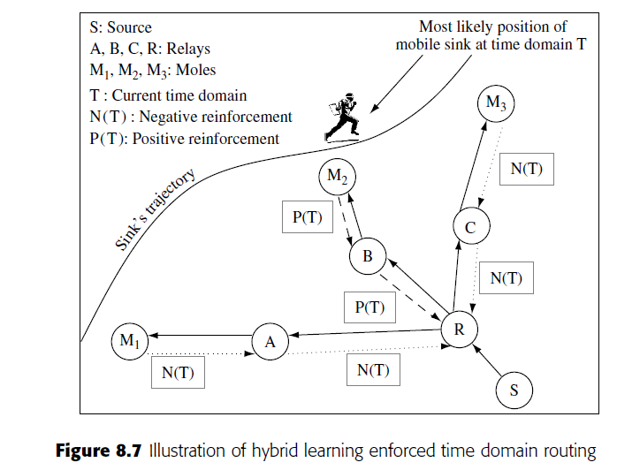

Data-centric networking
OVERVIEW
A fundamental innovation in the area of wireless sensor networks has been the concept of data-centric networking. In a nutshell, the idea is this: routing, storage, and querying techniques for sensor networks can all be made more efficient if communication is based directly on application-specific data content instead of the traditional IP-style addressing.
Consider the World Wide Web. When one searches for information on a popular search site, it is possible to enter a query directly for the content of interest, find a hit, and then click to view that content. While this process is quite fast, it does involve several levels of indirection and names: ranging from high-level names, like the query string itself, to domain names, to IP (internet protocol) addresses, and MAC addresses. The routing mechanism that supports the whole search process
is based on the hierarchical IP addressing scheme, and does not directly take into account the content that is being requested. This is advantageous because the IP is designed to support a huge range of applications, not just web searching. This comes with increased indirection overhead in the form of the communication and processing necessary for binding; for instance the search engine must go through the index to return web page location names as the response to the query string,
and the domain names must be translated to IP addresses through DNS.
This tradeoff is still quite acceptable, since the Internet is not resource constrained. Wireless sensor networks, however, are qualitatively different. They are application specific so that the data content that can be provided by the sensors is relatively well defined a priori. It is therefore possible to implement network operations (which are all restricted to querying and transport of raw and processed sensor data and events) directly in terms of named content. This data-centric approach to networking has two great advantages in terms of efficiency:
1. Communication overhead for binding, which could cause significant energy wastage, is minimized.
2. In-network processing is enabled because the content moving through the network is identifiable by intermediate nodes. This allows further energy savings through data aggregation and Compression.
Data-centric routing

- Directed diffusion

One of the first proposed event-based data-centric routing protocols for WSN is the directed diffusion technique (Figure 9.1). This protocol uses simple attribute-based naming as the fundamental building block. Both requests for information (called interests) and the notifications of observed events are described through sets of attribute–value pairs. Thus, a request for 10 seconds worth of data from temperature sensors within a particular rectangular region may be expressed as follows:
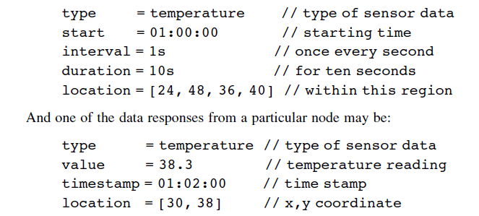
The steps of the basic directed diffusion are as follows:
1. The sink issues an interest for a specific type of information that is flooded throughout the network (the overhead of this can be reduced if necessary by using geographic scoping or some other optimization). The interest may be periodically repeated if robustness is called for.

2. Every node in the network caches the interest while it is valid, and creates a local gradient entry towards the neighboring node(s) from which it heard the interest. The sink’s ID/network address is not available and hence not recorded, however the local neighbors are assumed to be uniquely identifiable through some link-layer address. The gradient also specifies a value (which could be an event rate, for instance).

3. A node which obtains sensor data that matches the interest begins sending its data to all neighbors it has gradients toward. If the gradient values stand for event rates then the rate to each neighbor must satisfy the gradients on the respective link. All received data are cached in intermediate nodes to prevent routing loops.
4. Once the sink starts receiving response data to its interest from multiple neighbors, it begins reinforcing one particular neighbor (or k neighbors, in case multi-path routing is desired), requesting it to increase the gradient value (event rate). These reinforcements are propagated hop by hop back to the source. The determination of which neighbor to reinforce can take into account other considerations such as delay, link quality, etc. Nodes continue to send data along the outgoing gradients, depending on their values.
5. (Optional) Negative reinforcements are used for adaptability. If a reinforced link is no longer useful/efficient, then negative reinforcements are sent to reduce the gradient (rate) on that link. The negative reinforcements could be implemented by timing out existing gradients, or by re-sending interests with a lower gradient value.

2. Pull versus push diffusion

The basic version of directed diffusion described above can be viewed as a two phase pull mechanism. In phase 1, the sink pulls for information from sources with relevant information by propagating the interest, and sources respond along multiple paths; in phase 2, the sink initiates reinforcement, then sources continue data transfer over the reinforced path. Other variants of directed diffusion include the one-phase pull and the push diffusion mechanisms. The two-phase pull diffusion can be simplified to a one-phase pull mechanism by eliminating the reinforcements as a separate phase. In one-phase pull diffusion, the sink propagates the interest along multiple paths, and the matching source directly picks the best of its gradient links to send data and so on up the reverse path back to the sink. While potentially more efficient than two phase pull, this reverse-path selection assumes some form of bi directionality in the links, or sufficient knowledge of the link qualities/properties in each direction. In push diffusion, the sink does not issue its interests. Instead sources with event detections send exploratory data through the network along multiple paths.
The sink, if it has a corresponding interest, reinforces one of these paths and the data-forwarding path is thus established. The push and pull variants of diffusion have been compared and analyzed
empirically as well as through a simple mathematical model . The results quantify the intuition that the pull and push variants are each appropriate for different kinds of applications. In terms of the route setup overhead, pull diffusion is more energy-efficient than push diffusion whenever there are many sources that are highly active generating data but there are few, infrequently interested sinks; while push diffusion is more energy-efficient whenever there are few infrequently active sources but there are many frequently interested sinks.
The threshold-sensitive energy-efficient sensor network protocol (TEEN) is another example of a push-based data-centric protocol. In TEEN, nodes react immediately to drastic changes in the value of a sensed attribute and when this change exceeds a given threshold communicate their value to a cluster-head for forwarding to the sink.

Data-gathering with compression

Several researchers have investigated the combination of gathering information in a WSN by combining routing with in-network compression. While the exact type of compression involved can be quite application specific, these studies reveal a number of general principles and the tradeoffs involved. In most of these studies, the efficiency metric of interest is the total number of data bit
transmissions (i.e. cumulative number of bits over each hop of transmission) per round of data-gathering from all sources. Besides providing energy efficiency by reducing the amount of transmissions, combining routing with compression also has the potential to improve network data throughput in the face of bandwidth constraints. We now describe some of the pertinent techniques and analytical studies.

- LEACH

The LEACH protocol is a simple routing mechanism proposed for continuous data-gathering applications. In LEACH, illustrated in Figure 9.2, the network is organized into clusters. The cluster-heads periodically collect and aggregate/compress the data from nodes within the cluster using TDMA, before sending them to the sink. The cluster-heads may send to the sink through a direct
transmission or through multiple hops. Cluster-heads are rotated periodically for load balancing.
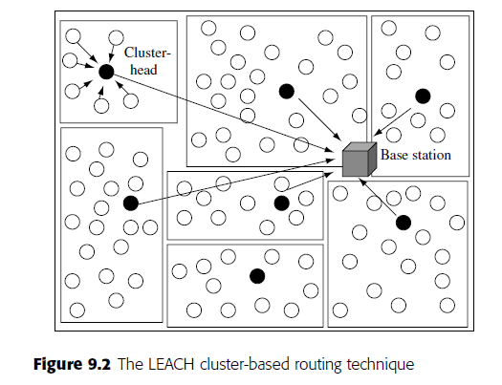

network is organized into clusters. The cluster-heads periodically collect and aggregate/compress the data from nodes within the cluster using TDMA, before sending them to the sink. The cluster-heads may send to the sink through a direct transmission or through multiple hops. Cluster-heads are rotated periodically for load balancing.

- Distributed source coding

There exist distributed source coding techniques based on the Slepian–Wolf theorem that allow joint coding of correlated data from multiple sources without explicit communication, so long as the individual source rates satisfy certain constraints pertaining to different conditional entropies. These techniques require that the correlation structure be available in advance at the independent coders. While this approach increases the complexity of the coding and requires upfront collection of information about joint statistics (which may not be feasible in all practical conditions), it effectively makes routing and coding decisions independent of each other, since the independently coded data can be sent along the shortest paths to the sink. In a networked context, then, the only design
consideration for energy efficiency is to ensure that sources near the destination are allocated higher rates .

- Impact of compression

The gains due to in-network compression can be best demonstrated in the extreme case where the data from any number of sources can be combined into a single packet (e.g. duplicate suppression, when the sources generate identical data). In this case, if there are k sources, all located close to each other and far from the sink, then a route that combines their information close to the sources can achieve a k-fold reduction in transmissions, as compared with each node sending its information separately without compression. In general, the optimal joint routing–compression structure for this case is a minimum Steiner tree construction problem, which is known to be NP-hard. However there exist polynomial solutions for special cases where the sources are close to each other..
- Prediction-based compression

Another approach to combining routing and compression is to perform prediction based monitoring . The essence of this idea is that the base station (or a cluster-head for a region of the network) periodically gathers data from all nodes in the network, and uses them to make a prediction for data to be generated until the next period. In the simplest case, the prediction may simply be that the data do not change. More sophisticated predictions may indicate how the data will change over time (e.g. the predictions may be based on the expected movement trajectory of a target node, or in the case of diffuse phenomena such as heat and chemical plumes, these predictions may even be based on partial differential equations with known or estimated parameters). This prediction is then broadcast to all nodes within the region. During the rest of the period, the component nodes only transmit information to the base station if their measurements differ from the predicted measurements.

Querying

In basic data-gathering scenarios, such as those discussed above in connection with compression, information from all nodes needs to be provided continuously to the sink. In many other settings, the sink may not be interested in all the information that is sensed within the network. In such cases, the nodes may store the sensed information locally and only transmit it in response to a query issued
by the sink. Therefore the querying of sensors for desired information is a fundamental networking operation in WSN. Queries can be classified in many ways:
1. Continuous versus one-shot queries: depending on whether the queries are requesting a long duration flow or a single datum.
2. Simple versus complex queries: complex queries are combinations that consist of multiple simple sub-queries (e.g. queries for a single attribute type); e.g. “What are the location and temperature readings in those nodes in the network where (a) the light intensity is at least w and the humidity level is between x and y OR (b) the light intensity is at least z.” Complex queries may also be aggregate queries that require the aggregation of information from several sources; e.g. “report the average temperature reading from all nodes in region R1.”
3. Queries for replicated versus queries for unique data: depending on whether the queries can be satisfied at multiple nodes in the network or only at one such node.
4. Queries for historic versus current/future data: depending on whether the data being queried for were obtained in the past and stored (either locally at the same node or elsewhere in the network), or whether the query is for current/ future data. In the latter case data do not need to be retrieved from storage.

1. Expanding ring search

One option is the use of an expanding ring search, illustrated in Figure 9.3.An expanding ring search proceeds as a sequence of controlled floods, with the radius of the flood (i.e. the maximum hop-count of the flooded packet) increasing at each step if the query has not been resolved at the previous step. The choice of the number of hops to search at each step is a design parameter that can be optimized to minimize the expected search cost using a dynamic programming technique .
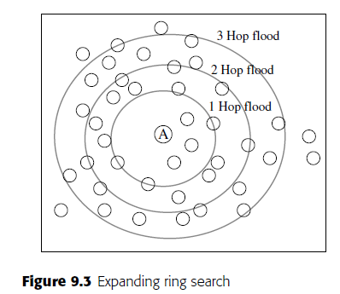
However, in the absence of replicated/cached information in the network, for arbitrarily located data, expanding ring searches do not provide useful gains over flooding. This is demonstrated in , which shows that less than 10% energy savings are obtained from expanding ring search compared with flooding when there is no caching/replication of data in the network, while the delay increases significantly. Intuitively, when there is replicated information, expanding ring searches are more likely to offer significant improvements, because the likelihood of resolving the query earlier would be higher. However, in this situation, other approaches may potentially provide better improvements.
- Trajectory-based forwarding (TBF)

In WSN where nodes in the network all have reasonably accurate location information (either directly through GPS or through the implementation of a network localization technique), a unique approach to efficient querying is the use of pre-programmed paths embedded into the query packet. The geographic trajectory-based forwarding (TBF) technique provides this functionality. The source encodes a trajectory for the query packet into the header. The trajectory could be anything that can be represented in a parametric form (x(t),y(t)) though non-parametric representations are also possible in principle).
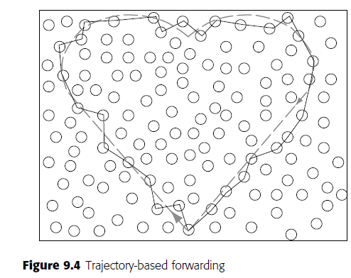

- Active query forwarding (ACQUIRE)

ACQUIRE is a querying technique involving active query forwarding. The idea is to treat the query as an intelligent entity that moves through the network searching for the desired response. If the query is a complex query, its component sub-queries can be resolved partially en route. As shown in Figure 9.5,ACQUIRE progresses through the network as a repeated sequence of three parts:

1. Examine cache: When the query arrives at a node in the network (referred to as an active node), the node first checks its existing cache to see if its cache is valid/fresh enough to directly resolve the query (or parts of it). If the entire query can be resolved from the active node’s cache, the response is returned to the sink, else the process continues as follows.

2. Request updates: If the cache does not contain the information desired, the active node issues a request for updates from nodes within a d-hop neighborhood. The responses from the controlled flood are then gathered back and used to see if the query can be resolved.

3. Forward: If it has not already been resolved, the query is then forwarded to another active node (chosen either randomly or through some guided mechanism such as TBF) by a sufficient number of hops so that the controlled flood phases (described below) do not overlap significantly.

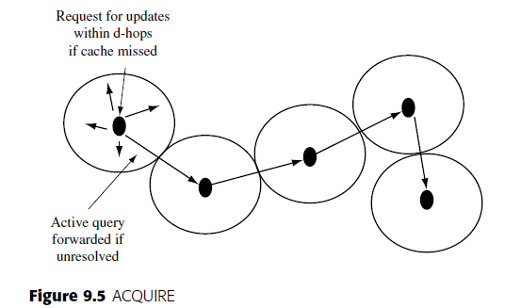

- Rumor routing

The rumor routing technique provides an efficient rendezvous mechanism to combine push and pull approaches to obtain the desired information from the network. In rumor routing, sinks desiring information send queries through the network, while sources generating important events send notifications through the network. These are both treated as mobile agents. The event notifications
leave a “sticky” trail of state information through the network. Then, a query agent visiting a node where an event notification agent has already passed will find pointer information on the location of the corresponding source. This is shown in Figure 9.6.
Thus, it suffices for the queries to simply intersect with one of the event notification trajectories, rather than have to locate the event node itself. An additional optimization provided is the ability of event notification agents to propagate information about other events based on the state encountered in intermediate nodes, which can reduce the number of unique agents generated for
each event.
The trajectory followed by both the events and the queries can be either a random walk (with some loop-prevention built in), or more directed, e.g. straight lines generated using a TBF scheme. It is shown that substantial improvements in the energy costs can be obtained by rumor routing compared with the two extremes of query flooding (pull) and event flooding (push).
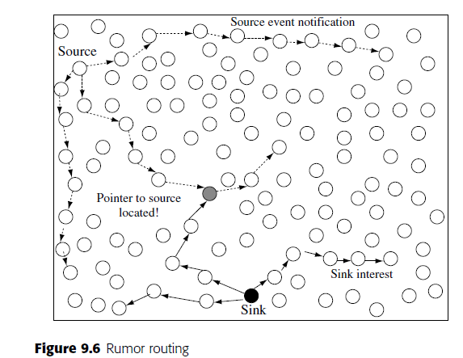

- The comb-needle technique

The same approach as followed by rumor routing, of combining push and pull by looking at intersections of queries and event notifications, is also the basis of the comb-needle technique.
In the basic version of this technique, illustrated in Figure 9.7 the queries build a horizontal comb-like routing structure, while events follow a vertical needlelike trajectory to meet the “teeth” of the comb. A key tunable parameter in this construction is spacing between branches of the comb and correspondingly the length of the trajectory traversed by event notifications, which can be adjusted
depending on the frequency of queries as well as the frequency of events. To minimize the average total cost per query, the comb inter-spacing as well as the length of the event trajectories should be smaller when the event-to-query ratio is higher (more pull, less push); however, when there the event-to-query ratio is lower, the comb inter-spacing as well as the distance traversed by even notifications should be higher (less pull, more push). In practice, the frequency of both queries and events is likely to fluctuate over time. An adaptive version of the algorithm handles this scenario. In this adaptive technique, the inter-comb spacing and needle trajectory length are calculated and adjusted dynamically in a distributed manner by the sources and sinks by locally estimating data and query frequencies over several observations. The basic comb structure, with the queries forming the horizontal comb and events the vertical needles is a global-pull, local-push model, best suited for conditions when the frequency of queries is less than the frequency of events.
When the frequency of queries is more than the frequency of events, and there are multiple querying nodes, then a reverse-comb structure can be employed, which would provide a global-push, local-pull structure. In the reverse-comb structure, the events form the vertical comb, while queries take horizontal needle trajectories to match with events.
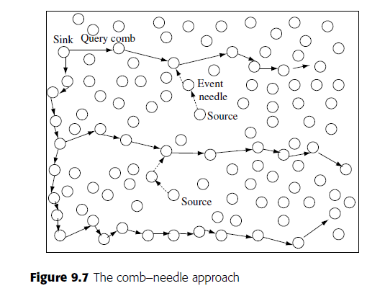
Data-centric storage and retrieval
Another approach to data-centric networking is to decouple the sensor data storage location from the location where the data are generated. In this structured approach, storage location is carefully chosen based on the type and value of the corresponding data. Instead of blind querying, this enables more efficient retrieval of desired information. It also avoids the overheads associated with pure push-based schemes, where all the data are sent to the sink, regardless of whether they are needed.
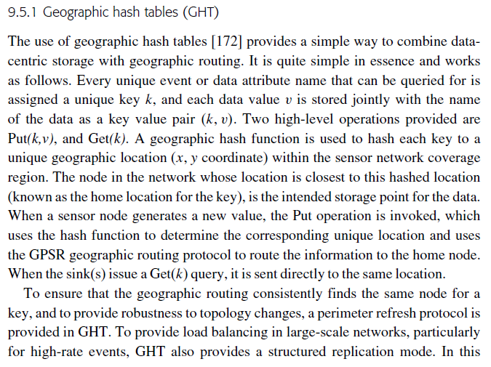

mode, instead of a single location, for each unique key a number of symmetric hierarchical mirror locations are chosen throughout the network. When a node generates data corresponding to the key, it stores it at the closest mirror location, while queries are propagated to all mirror locations in a hierarchical manner.
- Distributed index for features (DIFS)

DIFS is a technique suitable for index-based storage and retrieval of information in response to range queries (e.g. “did any sensors report readings of temperatures within 20–30 degrees?”). DIFS constructs a multiply rooted hierarchical index as follows. Nodes store information for a range of values in a given geographic region. Nodes at low levels cover a wide range of values within a small region, while nodes at the higher levels cover a small range of values within a larger region. In DIFS, each parent has exactly four children, while each child has k parents. Each parent holds information on 1/k of the values that a child does, but covers four times its geographic range. A source node measuring an event sends it first to the nearby local index node (determined by a suitable hash function) with a small area coverage and largest range of values. This node then propagates a histogram of observed values to the particular parent at the next higher level with a smaller range of values covering that value, and so on. The leaf index nodes at level 0 point directly to storage nodes, while nodes at level 1 and higher each store four histograms pointing to each of the lower-level index nodes covering smaller areas. DIFS searches may enter at any level of the index structure (and often at multiple points), depending on the spatial extent and value range requested in the query, and drill down to obtain events satisfying the query. The histograms are also useful in resolving more sophisticated queries involving distributions.

The database perspective on sensor networks
So far we have been focusing on a bottom–up networking-centric view of WSN, with an emphasis on networking mechanisms such as routing and query forwarding, albeit enhanced with data-centric notions of in-network processing, data management, storage, and efficient retrieval of queried information. A complementary, top–down perspective is to view sensor networks as a distributed
database system, and place the primary emphasis on the interface between the end user (i.e., the human querying the system) and this system. Several researchers have advocated this alternate perspective.
- Query language

It has been shown that a simple SQL-like declarative language with some extensions can be quite powerful for phrasing a diverse set of queries relevant to sensor networks. The canonical example of such a query approach is the TinySQL /TinyDB implementation of a tiny aggregation service (TAG) .
In Tiny DB/TAG, all nodes in the network are treated as forming a single table, called sensors. The columns of the table are all the attributes defined for the network and application (e.g. these may be metadata like node ID, location ID, time Stamp, as well as data readings from the different sensors, such as temperature, light, etc.).
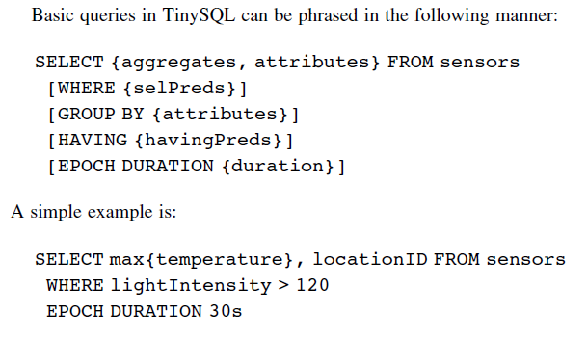
The query thus formulated is then flooded through the network and the pertinent information is sent from the nodes that satisfy the relevant predicates. Aggregation operations are applied within the network en route, as the data return to the querying sink (more on this below). The basic TinySQL language is already quite expressive, enabling users to formulate a wide variety of useful queries. Further enhancements have been proposed. The first is the addition of an event-driven query mechanism, allowing a construct like:
ON EVENT fire-detected
SELECT max{temperature}, location ID FROM sensors
...
